Mission Portfolio
______________________
Personal information
Student name: Jean Robert Gatwaza
Email: j.gatwaza@alustudent.com
Academic information
Academic program: BSE
Mission-related information
Mission Capstone Project Title: Unattended attention.

Grand challenge or great opportunity (GCGO): Healthcare, regional integration, and education

Mission statement (maximum 60 words): My mission is to build inclusive and ethical socio-economic systems for Sub-Saharan Africa, where small daily decisions and local actions accumulate into sustainable prosperity and well-being.

Narrative
Please write a short narrative of your mission development journey over the course of three years. This could be a summary of the activities that you mention in the table below, with emphasis on the lessons learned and key achievements (maximum 200 words).

When I started at the ALU my mission was clear innovate solutions that impact social economic standards of my community through investment awareness and platform to do so, hardly first year my colleague and I were able to prototype this STOKO platform that was intended to fulfill that mission directly, however the universe had another plan eventually after multiple events participations, resources available, opportunities, challenges we kept meeting along the line, the mission shifted a bit into healthtech where I cofounded MediXR from the on campus hackathon which had personal mission to address shortage of infrastructure to train on scale medical expertise to meet demand to the rising population on African continent on the side note I worked with another team healthtech solution UNESIS AI which intended to address the lack of proper medical care due to the lack of communication in refugees camps from diverse individual who has numerous language background and diagnosing capacity after that the mission stayed on improving the left behind while addressing inherent social community issues which leads to more focused and refined mission of building systems that improve social economic standard while proper drawing insights from small and daily actions bleeding sustainable prosperity.
A List of experiential learning activities in line with the student mission attended
(Please delete the example once you have entered your list of activities)
Date/period | Activity (in max. 40 words) | Duration | The organization that hosted the activity | Student’s deliverables | Proof of participation (insert link for certificate of participation, email, or reference letter)
July 2022 | I enrolled in and completed the Corporate Finance Essentials 1 MOOC offered by IESE Business School. The course focused on core financial principles and their application in corporate and capital market contexts. | 2 weeks | IESE Business School, University of Navarra | - Completed all course modules, including topics such as Risk and Return, Correlation and Diversification, The CAPM and the Cost of Capital, Project Evaluation, and Corporate Value Creation  -Submitted graded assignments featuring multiple-choice, short answer, long answer, and math-based questions to assess understanding of key concepts  - Gained practical knowledge in interpreting financial data and using professional financial vocabulary  - Developed the ability to understand financial news and apply theoretical concepts to real-world corporate finance scenarios | Link
Hosted my first masterclass: Fun Lab, March 2022. | My colleague & I volunteered to host a masterclass on financial investment schemes in leadership with over 30 participants at ALU titled life of Wall Street. | 1 day | African Leadership University | - Enrolled 30 participants and honed participants’ skills in investment awareness and local available public assets markets to participate in.  - Full covered local financial market like RSE and moved to the global NYSE, and showcasing the unique each one of them provide. | 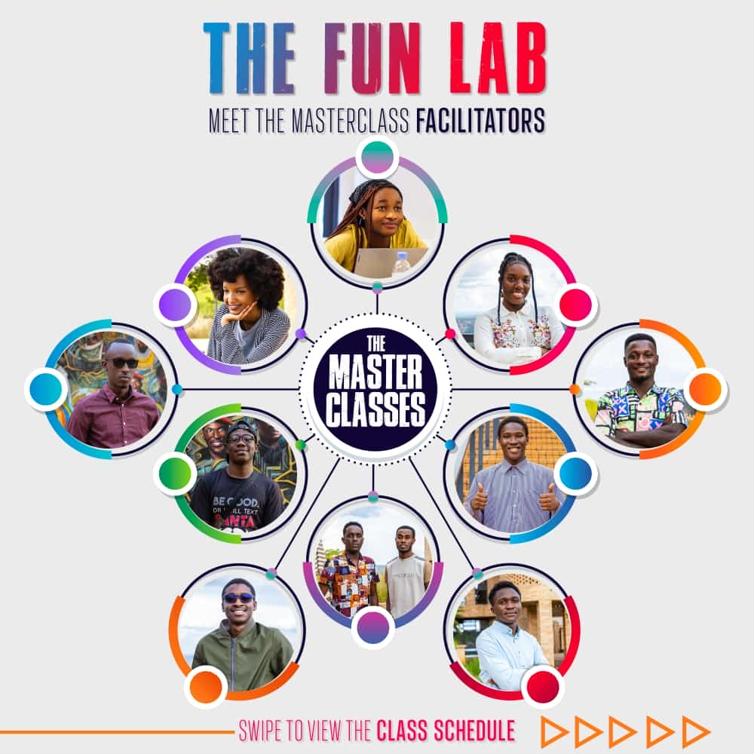
Took part in Startup Weekend Kigali, July 2022. | The Jasiri fellows introduced entrepreneurship and provided knowledge to build startups. | 1 day | African Leadership University | - Developed design thinking for entrepreneurs that varies from empathize, define, ideate, prototype, and test. | Startup Weekend Kigali
Tech Forum One by Wakuma. Nov 2022. | This designed tech forums to bring experts from various fields of tech to impart their skills and their long professional journey, what tools to leverage along the way. | 3 days | African Leadership University. | - Learned from seasoned guest speaker Mikias Tilahun, a software engineer who shared his wisdom about their tech journey.  - Explored their built payment integration API Semuny, and how one can full develop one. | Tech Forum - Building Career in SE
Sept 2022 | Participated in the first hackathon challenge with team named Legion and won. | 3 Days | African Leadership University | - Teamwork  - Build for prototyping  - Pitching  - Financial support after winning. | AR/VR Metathon
Feb 2023 - France | Invitation to participate in ReVolution#Students - Limited Time competition | 3 Days | African Leadership University | - Attended the competition virtually and competed for two consecutive days  - Build on an iterated prototype.  - Exhibition opportunity. | Laval Virtual 2023
March 2023 | For the first time, I participated in #Dohardthigs Challenge in FounderAcademy | 6 months | ALX Ventures | - Incubation & Accelerator program.  - Developed ready business papers  - Refined pitchdeck, lean canvas, competitive analysis, customer acquisitions, business plan, and financial projections.  - Prototype iteration development schemes.  - - Financial support after winning. | Founder's Academy
May 2023 | My team represented ALU for the Fowler Global Social Innovation Challenge. An opportunity to network with fellow entrepreneurs, gain insights, and present this idea to a global audience. | 3 days | ALU | - Pitching and financial support after winning.  - during the challenge.  - Refined pitchdeck & articulated idea to implementation. | Fowler Global Innovation Challenge
August 2023 | Attended data science masterclass prepared by visiting experts programme. | 5 days | African Leadership University | - Data gathering  - Data manipulation techniques  - Data exploration  - Data visualization  - Modeling techniques  - Drawing insights | Data Science Masterclass
Oct 2023 | Attended ALN Annual Gathering themed beats of boldness that brought executives, leaders and decision makers all across the world. | 3 Days | KCC | - Corporate strategy  - Leading with cause  - Investment readiness | ALN Annual Gathering
Nov 2023 | Innovation Africa Summit Youth Innovation a ministerial forum under the invitation from Ministry of ICT & Ministry of Education | 3 days | KCC | - Innovations in education  - Role of stakeholders in innovation  - Presented before a ministerial audience(policy decision makers). | Innovation Africa Summit Youth Innovation Showcase
April 2024 | Hult Prize 2024 Dubai Summit SELECTED 360 startups, and my team was one of them | 3 days | Dubai | - Benefited from a wide network of Hult Prize, from country directors to regionals  - Received valuable feedbacks  - Exposure &guidance from experienced professionals. | Hult Prize 2024 Dubai Summit invitation
Jun 2024 | Participated in AI Symposium masterclasses and a hackathon, which my team won 1st place with a tool to translate and diagnose in a refugee camp | 3 days | ALU | - Chatbot exploring  - Agentic AI comprehension  - Fine-tuning and reinforcement learning techniques  - Developed and iterated with a team.  - Pitched and financial support after winning. | Selected AI Symposium at ALU
Exclusive Invitation: Showcasing MediXR at Web Summit Qatar 2024 | Through FutureList, I was able to represent MediXR on global exposure in Qatar Web Summit 24, as one of the most innovative African tech startups to exhibit, pitch, and demo. | 3 days | Qatar | - Global Exposure  - Networking opportunities  - Investment and pitching | Showcasing MediXR at WSQ 24
Feb 24, 2025 | I was selected to attend the GLP at ALU’s Silicon Valley Hub 2025, which brought participants from the African Leadership Group to seek innovative, entrepreneurial, and leadership knowledge on the global hub of Silicon Valley. | 3 months | California, Silicon Valley. | - The goal was to discover and unpack the unique entrepreneurial environment of Silicon Valley.  - See what works elsewhere, and how approaching our unique wicked problem could be. | GLP at ALU's Silicon Valley HUb
IRC Expo - Nov 2025. | I participated in the international Research Commercialization, Cairo, bringing inventors, startups, universities, research institutions, industry leaders, and international speakers. | 2 days | Egypt | - Exhibits and matchmaking, facilitating partnerships, and accelerating technology commercialization across diverse sectors and ecosystems.  - Cultural blending and scaling capacity identified. | IRC Expo

